Cluster Practice 2 Census2000

1. Added **Filter** in diagram.

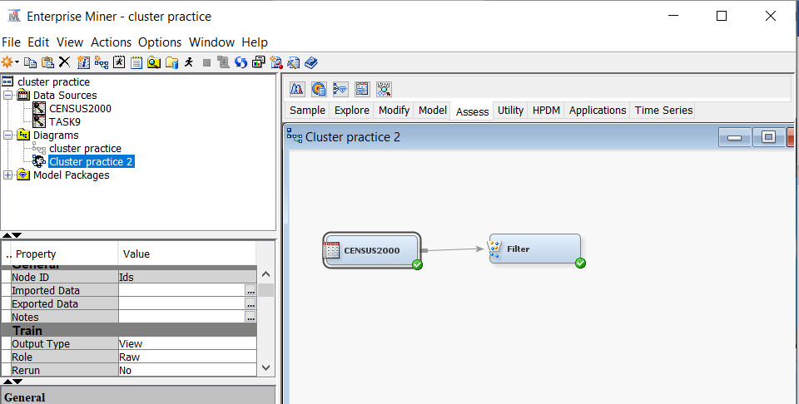

1. Change **Default Filtering Method** as in below. Then click on  **Interval Variable** . and change the **Filter Lower Limit** of **MedHHInc** to **0.1**.

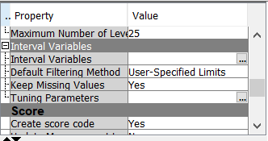

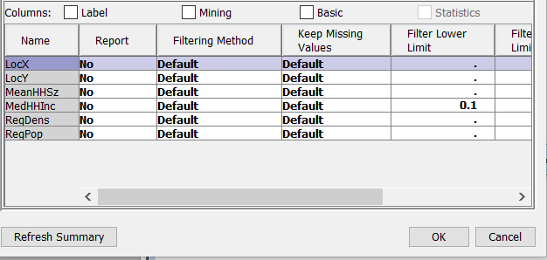

1. Run and display the result.

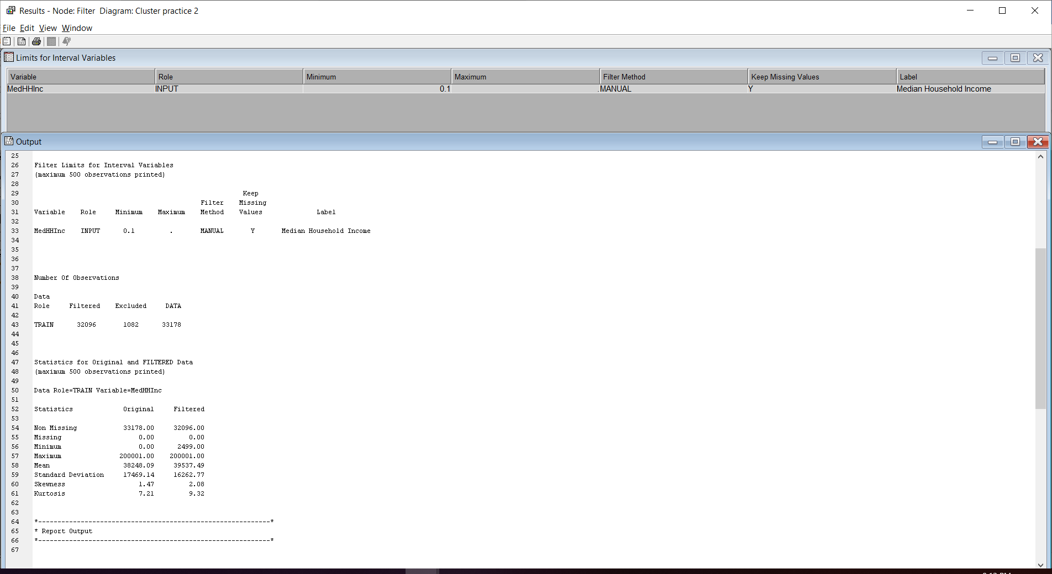

1. Add **Cluster** to diagram and set the **Use** for **LocX, LocY** and **RegPop** to **No.** 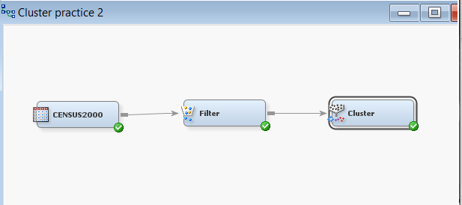

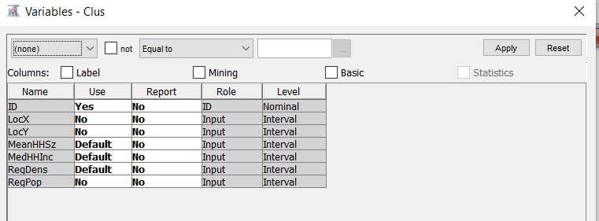

1. Run and display the result.

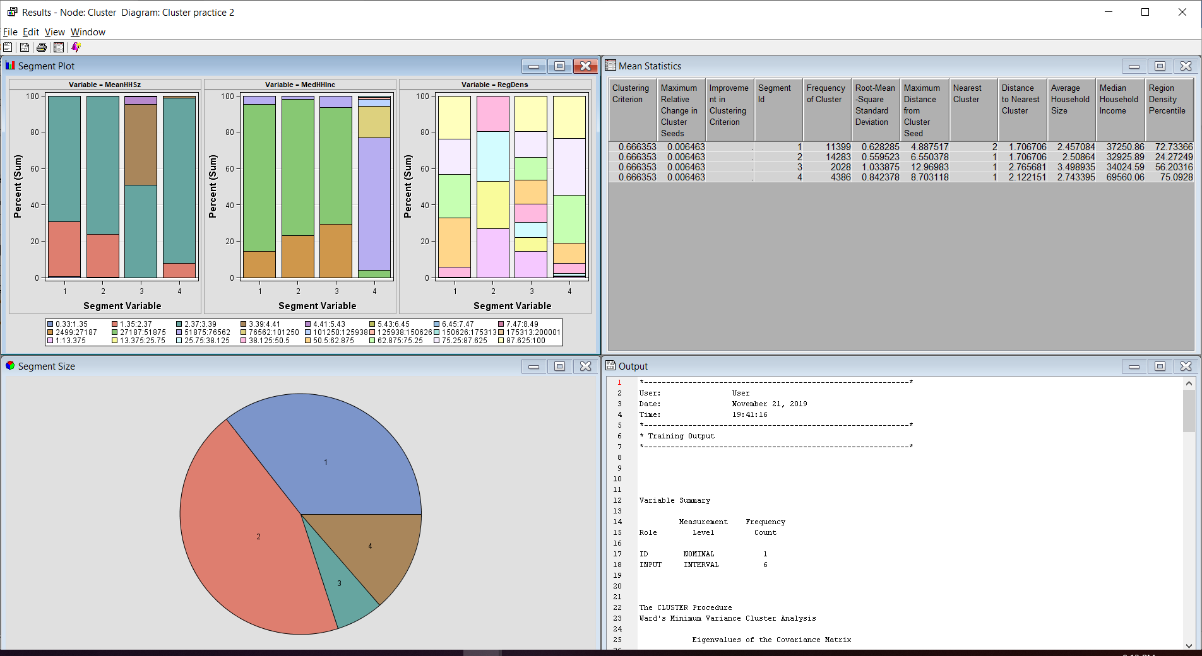

1. Click View >> Summary Statistic >> CCC Plot.

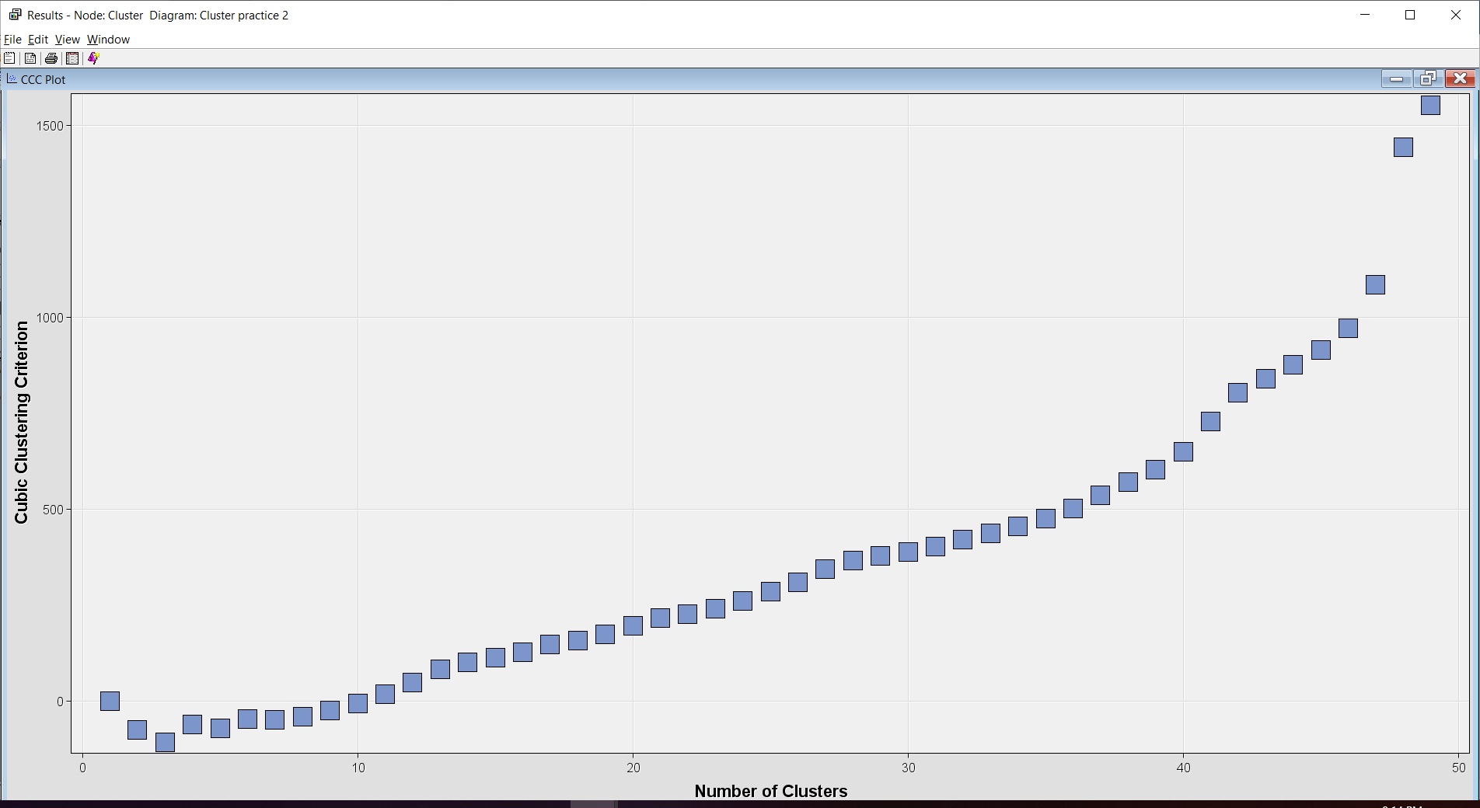

1. Add the **Segment Profile** and change **Use** for **LocX**,**LocY**,**RegPop** to **No**.

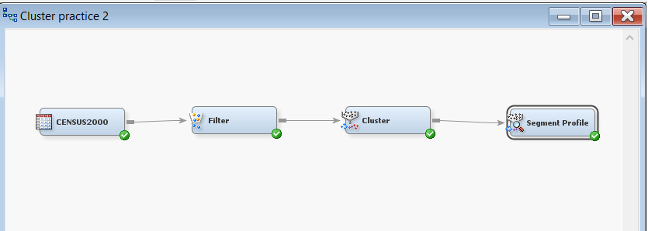

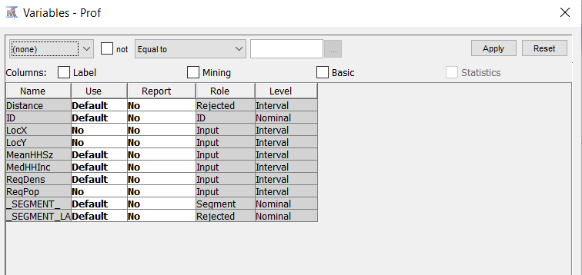

1. Run and display the result.

